Question物件 java.util.List的依賴注入(Dependency Injection)

這裡我們要注入List Question物件
我們在這裡建立了三個文件：
- Question.java (Model)
- applicationContext.xml (bean 屬性設定檔案)
- Spring Controller

package model;

import java.util.Iterator;
import java.util.List;

public class Question {
private int id;
private String name;
private List<String> answers;

public Question() {
}

public Question(int id, String name, List<String> answers) {

this.id = id;
this.name = name;
this.answers = answers;
}

public void displayInfo() {
System.out.println(id + " " + name);
System.out.println("answers are:");
Iterator<String> itr = answers.iterator();
while (itr.hasNext()) {
System.out.println(itr.next());
}
}

@Override
public String toString() {
return "Question [id=" + id + ", name=" + name + ", answers=" + answers + "]";
}
}
建立 src/main/resources 資料夾
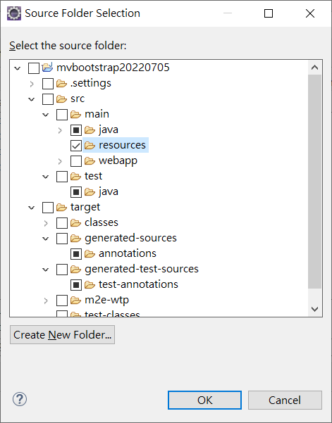
產生一個applicationContext.xml
<?xml version="1.0" encoding="UTF-8"?>
<beans xmlns="http://www.springframework.org/schema/beans"
xmlns:xsi="http://www.w3.org/2001/XMLSchema-instance"
xmlns:p="http://www.springframework.org/schema/p"
xsi:schemaLocation="http://www.springframework.org/schema/beans http://www.springframework.org/schema/beans/spring-beans-3.0.xsd">
<bean id="qt" class="model.Question">
<constructor-arg value="11"></constructor-arg>
<constructor-arg value="What is java?"></constructor-arg>
<constructor-arg>
<list>
<value>Java is a programming language</value>
<value>Java is a Platform</value>
<value>Java is an Island of Indonasia</value>
</list>
</constructor-arg>
</bean>
</beans>
Controller:

import org.springframework.context.ApplicationContext;
import org.springframework.context.support.ClassPathXmlApplicationContext;
import org.springframework.stereotype.Controller;
import org.springframework.ui.ModelMap;
import org.springframework.web.bind.annotation.RequestMapping;
import org.springframework.web.bind.annotation.RequestMethod;

import model.*;
@Controller
public class QuestionController {

@RequestMapping(value="/qtlist",method = RequestMethod.GET)
public String myQuestionObj(ModelMap model) {
ApplicationContext context = new ClassPathXmlApplicationContext("applicationContext.xml");
Question obj = (Question) context.getBean("qt");

model.addAttribute("greeting", obj.toString());

return "emp";
}

}
Emp View:
<%@ page language="java" contentType="text/html; charset=UTF-8"
pageEncoding="UTF-8"%>
<!DOCTYPE html>
<html>
<head>
<meta charset="UTF-8">
<title>Spring DI Bean</title>
</head>
<body>
Controller : ${greeting}
</body>
</html>

